Loknete Hon. Hanmantrao Patil Charitable Trust’s
ADARSH INSTITUTE OF TECHNOLOGY AND RESEARCH CENTRE ,VITA
MSBTE- 0991

FIVTH SEMESTER (Year: 2023-24)
Micro Project

Software Testing (22518)

Title of the Project: “Vaccination Management System”
Branch: “Computer Technology”CM5I)

Members of the Group:

Sr. No. | Name of Student | Roll No.
01 | Mulla Asiya Umarfaruk | 3133
02 | Deepak Nikam Laxman | 3134
03 | Arman Ikbal Jamadar | 3135
04 | Satyajeet Laxman Mahind | 3136

Loknete Hon. HanmantraoPatil Charitable Trust’s Adarsh Institute of Technology & Research Centre Vita,


CERTIFICATE
This is to certify that he micro project report entitled
“Vaccination Management System”
Submitted by
Sr. No. | Name of Student | Roll No.
01 | Mulla Asiya Umarfaruk | 3133
02 | Deepak Nikam Laxman | 3134
03 | Arman Ikbal Jamadar | 3135
04 | Satyajeet Laxman Mahind | 3136

For Fivth Semester of Diploma in Computer Technology of course Software Testing (22518) for academic year 2023-24 as per MSBTE, Mumbai curriculum of ‘I’ scheme.

DIPLOMA OFENGINEERING
(Computer Technology)

SUBMITTED TO
MAHARASHTRA STATE BOARD OF TECHNICAL EDUCATION MUMBAI ACADEMIC YEAR 2023-24

Project Guide | H.O.D. | Principal
Mrs.P.P.Yadav | Prof.A.A.Vankudre | Dr.P.S.Patil

MAHARASHTRA STATE BOARD OF TECHNICAL EDUCATION, MUMBAI

MICRO PROJECT
Progress Report / Weekly Report
Title of the Project: “Vaccination Management System”
Course: AJP(22517) Program: Computer Technology (CM5I)

Week No | Date | Duration in Hrs. | Work / Activity Performed | Sign of the  Faculty
1 |  | 2hour | Knowing the basic
2 |  | 1hour | Decide Aim
3 |  | 2hour | Collect the Data
4 |  | 2hour | Prepare project proposal
5 |  | 1hour | Search Literature review
6 |  | 1hour | Analysis of Data
7 |  | 1hour | Discussion over preparing
8 |  | 2hour | Correction in Booklets
9 |  | 2hour | Report writing
10 |  | 1hour | Checking report
11 |  | 1hour | Correction report write
12 |  | 1hour | Rechecking report
13 |  | 1hour | Finalizing report writing
14 |  | 1hour | Final submission
15 |  | 1hour | Oral presentation of micro project

Teacher Evaluation Sheet for Micro Project

Course Title and Code: - “Advance Java Programming” (22518) Title of the Project: “Vaccination Management System”

Group No: -9
COs addressed by the Micro Project:

CO a: | -
CO b: | Handle event of AWT and Swing components.
CO c: | Develop Java program using networking concepts.
CO d: | Develop program to handle even in java programming.
CO e: | -
CO f: | -

Marks:-

 | Name Of Student |  | Marks obtained
 | Name Of Student | Marks | by the | Total
Roll | Name Of Student | for | individual | Marks
No. | Name Of Student | Group | based on viva | (10)
 | Name Of Student | Work | (04)
 | Name Of Student | (06)
3133 | Mulla Asiya Umarfaruk
3134 | Deepak Nikam Laxman
3135 | Arman Ikbal Jamadar
3136 | Satyajeet Laxman Mahind

Name and designation of Faculty Member: Mrs.P.P.Yadav
Lecturer (Computer Technology Department)

Signature:

ACKNOWLEDGEMENT

I express my sincere gratitude to Mss.P.P.Yadav., Department of Computer Technology, for his/her stimulating guidance, continuous encouragement and supervision throughout the course of present work.

I would like to place on record my deep sense of gratitude to Prof.A.A.Vankudre
HOD- Department of Computer Technology, for his generous guidance, help and useful suggestions.
I am extremely thankful to Principal Dr.P.S.Patil for this motivation and providing me infrastructural facilities to work in, without which this work would not have been possible.

I would like to express my gratitude to all my colleagues for their support, co-operation and fruitful discussions on diverse seminar topics and technical help.

Name of Student | Sign
Mulla Asiya Umarfaruk
Deepak Nikam Laxman
Arman Ikbal Jamadar
Satyajeet Laxman Mahind

Index

Sr. No. | Content | Page No.
1.0 | Rationale
2.0 | Course Outcomes Addressed
3.0 | Literature Review
4.0 | Actual Methodology Followed
5.0 | Actual Resources Used
6.0 | Outputs of the Micro Project
7.0 | Skill Developed / learning out of this Micro Project
8.0 | Applications of this Micro Project
9.0 | Area of Future Improvement

PART A - Micro-Project Proposal

Title of Micro-Project: “Vaccination Management System”

Brief Introduction

Vaccines have changed the course of the medical system. The widespread availability of vaccines to mitigate illness or diseases has drastically changed over the last 20 years. These vaccines are used by Family doctors, Pediatricians, Internal Medicine, OBGYN, and many other medical experts in their medical practice in today's times. Moreover, the retail clinic and pharmacies administer vaccines in many states. There are some components to managing vaccines, including inventory management, supply chain management system, cold storage management system, and patient management system. Many Pediatric and other medical experts are still using either a manual process or paper process for inventory management & recording vaccines administration. Such manual processes take hours of time every month, and most have problems with consistency and accuracy. Earlier, some of the solutions on the market either delivered an intricate, time- intensive vaccine management process, and the solution rendered was costly to the office.

Medical facilities spend a considerable portion of their budget on buying vaccines for their patients. The discovery of new diseases has raised the cost of immunization every year. The hospitals can mitigate the vaccine wastage by proper maintenance and check of the patient's medical history. A vaccine management system is a one- stop solution for managing the immunization process in your medical center.

Aim of the Micro-Project

Some of the Benefits of the micro-project are as follows:

- The major purpose of this AJP Project to Give Information about acquiring knowledge about Advance java.
- This project also give knowledge about the Application and use of Advance Java in developing a billing system.
- State Importance of Advance Java & it’s features in platform independency.

Intended Course Outcomes
  - Handle event of AWT and Swing components.
  - Develop Java program using networking concepts.
  - Develop program to handle even in java programming.

Literature Review ]

Advance Java provides us the facility to create our own exceptions which are basically derived classes of Exception. Creating our own Exception is known as a custom exception or user- defined exception.
literature review aims to explore the existing literature on bank management systemsdeveloped using Java.

- Proposed Methodology

  - Knowing the basics of the topic.

  - Decide aim of the project and collect the data.

  - Prepare project proposal.

  - Search Literature reviews.

  - Analysis of data.

  - Discussion over preparing and correction in booklet and report.

  - Converting the content of project in report writing.

  - Checking and correction in report writing.

  - Rechecking and finalizing report writing.

  - Final submission and oral presentation of micro project.

- Resources Required

Sr.  No. | Name of Resource/ Material | Specifications | Quantity | Remark
1 | Computer System | i-5 | 1
2 | Microsoft Word | 2010 | 1
3 | Internet | Any | 1

- Action Plan

Sr.  No. | Details of activity | Planned start date | Planned Finish date | Name of Responsible Team Members
1 | Project Proposal |  |  | All Members
2 | Data Collection & Analysis |  |  | All Members
3 | Preparation of Prototype/ Model |  |  | All Members
4 | Preparation of Report |  |  | All Members
5 | Presentation & Submission |  |  | All Members

PART B - Micro- Project Proposal

Title of Micro-Project: “Vaccination Management System”

Rationale:
Vaccination Management system is a system for managing the vaccination procedure in an efficient way. It provides an easy way to people for registering, updating, viewing and deleting their slots. The main objective of this system is to createa user friendly system.

Course Outcomes Addressed:

- Develop programs using Object Oriented Methodology in java.
- Use AWT Component.
- Use SWING Component.
- Apply Event Handling Concepts.

3.0 Literature Review Review:
Advance Java provides us the facility to create our own exceptions which are basically derived classes of Exception. Creating our own Exception is known as a custom exception or user- defined exception.

literature review aims to explore the existing literature on bank management systems developed using Java.

4.0 Actual Methodology Followed:
Member 1): Name: All Members.
Work: Finalize the group & project
Member 2): Name: Deepak Nikam Laxman
Work: Search information regarding project subject.
Member 3): Name: Mulla Asiya Umarfaruk
Work: Collect information and discuss with group members about proposal. Prepare proposal and submit to the guide.
Member 4): Name: Arman Ikbal Jamadar
Work: Analyze and finalize the information of the project report

Member 5): Name: Deepak Nikam Laxman
Work: Write project report
Member 6): Satyajeet Laxman Mahind
Work: Prepare rough sketch and final chart

5.0 Actual Resources Used

Sr.  No. | Name of Resource/ Material | Specifications | Quantity | Remark
1 | Computer System | i-5 | 1
2 | Microsoft Word | 2010 | 1
3 | Internet | Any | 1

Source code

import javax.swing.*;
import java.awt.*;
import java.awt.event.*;
import java.sql.*;
import java.awt.Color.*;
class deleteslot2 extends JFrame implements ActionListener
{
JLabel l1, l2;
JTextField aadhar;
JButton delete, back;
Container c;
Connection con;
Statement stmt;
ResultSet rs;
deleteslot2()
{
setVisible(true);
Dimension screenSize = Toolkit.getDefaultToolkit().getScreenSize();
setSize(screenSize.width, screenSize.height);
setDefaultCloseOperation(EXIT_ON_CLOSE);
c = getContentPane();
Color c1 = new Color(230,230,250);
c.setBackground(c1);
c.setLayout(null);
l1 = new JLabel("Delete slot!!",JLabel.CENTER);
l1.setFont(new Font("Arial", Font.BOLD, 25));
l1.setSize(600, 30);
l1.setLocation(300, 20);
l1.setForeground(Color.red);
c.add(l1);
l2 = new JLabel("Enter Aadhar No");
l2.setFont(new Font("Arial", Font.BOLD, 15));
l2.setSize(600, 30);
l2.setLocation(450, 100);
c.add(l2);
aadhar = new JTextField(12);
aadhar.setFont(new Font("Arial", Font.BOLD, 15));
aadhar.setSize(150, 20);
aadhar.setLocation(580, 100);
c.add(aadhar);
delete = new JButton("Delete slot");
delete.setFont(new Font("Arial", Font.BOLD, 15));
delete.setSize(150, 20);
delete.setLocation(470, 170);
delete.addActionListener(this);
c.add(delete);
back = new JButton("Back");
back.setFont(new Font("Arial", Font.BOLD, 15));

back.setSize(150, 20);
back.setLocation(690, 170);
back.addActionListener(this);
c.add(back);
try
{
Class.forName("oracle.jdbc.driver.OracleDriver"); //register the driver
con =
DriverManager.getConnection("jdbc:oracle:thin:@localhost:1521:xe","system","TYCO");
//establish connection
stmt = con.createStatement(); //create Statement
}
catch(Exception e)
{
System.out.println(e);
}
}

public void actionPerformed(ActionEvent ae)
{
try
{
if(ae.getSource()==delete)
{
if(aadhar.getText().trim().length()>0)
{
int i = stmt.executeUpdate("Delete from Vaccine where ano = '"+aadhar.getText()+"'");
if(i>0)
JOptionPane.showMessageDialog(null,"Slot deleted successfully!!!");
}
else
JOptionPane.showMessageDialog(null,"Please enter valid aadhar number !!!");
}
else if (ae.getSource()==back)
{
DetailPagedemo dpg = new DetailPagedemo();
}
}
catch(Exception e)
{
System.out.println(e);
}
}
public static void main(String args[])
{
new deleteslot2();
}
}

2.

import java.awt.*;
import javax.swing.*;
import java.awt.event.*;
import java.awt.Color;
public class DetailPagedemo extends JFrame implements ActionListener
{
JLabel l1;
JButton register, update, view, delete;
public DetailPagedemo()
{
setLayout(null);
setVisible(true);
Dimension screenSize = Toolkit.getDefaultToolkit().getScreenSize();
setSize(screenSize.width, screenSize.height);
Color c = new Color(230,230,250);
setBackground(c);
l1 = new JLabel("Vaccination Management System!!");
l1.setBounds(150,100,850,80);
l1.setFont(new Font("Calibiri",20,40));
add(l1);
register = new JButton("REGISTER SLOT");
register.setBounds(350,250,150,50);
add(register);
register.addActionListener(this);
update = new JButton("UPDATE SLOT");
update.setBounds(350,350,150,50);
add(update);
update.addActionListener(this);
view = new JButton("VIEW SLOT");
view.setBounds(350,450,150,50);
add(view);
view.addActionListener(this);
delete = new JButton("DELETE SLOT");
delete.setBounds(350,550,150,50);
add(delete);
delete.addActionListener(this);
}

public void actionPerformed( ActionEvent ae)
{
if(ae.getSource()==register)
{
Registerslot rpg = new Registerslot();
}
if(ae.getSource()==update)
{
updateslot2 ups = new updateslot2();
}

if(ae.getSource()==view)
{
viewslot2 rpg = new viewslot2();
}
if(ae.getSource()==delete)
{
deleteslot2 rpg = new deleteslot2();
}
}
}

3. import java.awt.*;
import javax.swing.*;
import java.awt.event.*;
import java.awt.Color;
public class HomePage extends JFrame implements ActionListener
{
JButton jb1;
JLabel l1, l2, l3;
public HomePage()
{
Container cp = getContentPane();
cp.setLayout(null);
Color c = new Color(230,230,250);
cp.setBackground(c);
l3 = new JLabel("Welcome");
l3.setBounds(650,50,350,80);
l3.setFont(new Font("Calibiri",20,20));
l2 = new JLabel("Vaccination Management System!!");
l2.setBounds(450,200,850,80);
l2.setFont(new Font("Calibiri",20,40));
jb1 = new JButton("Next");
jb1.setBounds(650,350,130,30);
jb1.addActionListener(this);
cp.add(l2);
cp.add(l3);
cp.add(jb1);
}

public void actionPerformed( ActionEvent ae)
{
if(ae.getSource()==jb1)
{
LoginPage lp = new LoginPage();
}
}
public static void main(String args[])
{
HomePage hp = new HomePage();
hp.setVisible(true);
Dimension screenSize = Toolkit.getDefaultToolkit().getScreenSize();
hp.setSize(screenSize.width, screenSize.height);

hp.setTitle("Home Page");
hp.setDefaultCloseOperation(JFrame.EXIT_ON_CLOSE);
}
}

4.
import javax.swing.*;
import java.awt.*;
import java.awt.event.*;
import java.sql.*;
import java.awt.Color;
class Registerslot extends JFrame implements ActionListener
{
Container c;
JLabel l1, l3 ,l4, l5, l6, l7, l8, l9, l10, l11, l12;
JTextField fname, mno, age, aadhar;
JRadioButton male, female, covaxin, covishield, polio, rubela;
ButtonGroup gender, vaccine;
JComboBox date, dt, month, mth, yr, year, slot;
JTextArea address;
JButton register, back;
String dates[] = { "1", "2", "3", "4", "5",
"6", "7", "8", "9", "10",
"11", "12", "13", "14", "15",
"16", "17", "18", "19", "20",
"21", "22", "23", "24", "25",
"26", "27", "28", "29", "30",
"31" };
String months[] = { "Jan", "feb", "Mar", "Apr",
"May", "Jun", "July", "Aug",
"Sup", "Oct", "Nov", "Dec" };
String yrs[] = { "1995", "1996", "1997", "1998",
"1999", "2000", "2001", "2002",
"2003", "2004", "2005", "2006",
"2007", "2008", "2009", "2010",
"2011", "2012", "2013", "2014",
"2015", "2016", "2017", "2018",
"2019" };
String years[] = { "2021", "2022","2023" };
Connection cn;
Statement st;
Registerslot()
{
setDefaultCloseOperation(EXIT_ON_CLOSE);
Dimension screenSize = Toolkit.getDefaultToolkit().getScreenSize();
setSize(screenSize.width, screenSize.height);
setVisible(true);
c = getContentPane();
c.setLayout(null);
Color co = new Color(230,230,250);
c.setBackground(co);
l1 = new JLabel("Register slot!!",JLabel.CENTER);
l1.setFont(new Font("Arial", Font.BOLD, 25));
l1.setSize(600, 30);
l1.setLocation(320, 10);
l1.setForeground(Color.red);
c.add(l1);
l3= new JLabel("Full Name");
l3.setFont(new Font("Arial", Font.BOLD, 15));
l3.setSize(100, 20);
l3.setLocation(450, 100);
c.add(l3);
fname = new JTextField(30);
fname.setFont(new Font("Arial", Font.BOLD, 15));
fname.setSize(190, 20);
fname.setLocation(550, 100);
c.add(fname);
l4 = new JLabel("Mobile No.");
l4.setFont(new Font("Arial", Font.BOLD, 15));
l4.setSize(100, 20);
l4.setLocation(450, 150);
c.add(l4);
mno = new JTextField();
mno.setFont(new Font("Arial", Font.BOLD, 15));
mno.setSize(150, 20);
mno.setLocation(550, 150);
c.add(mno);
l10 = new JLabel("Aadhar No.");
l10.setFont(new Font("Arial", Font.BOLD, 15));
l10.setSize(100, 20);
l10.setLocation(450, 200);
c.add(l10);
aadhar = new JTextField();
aadhar.setFont(new Font("Arial", Font.BOLD, 15));
aadhar.setSize(150, 20);
aadhar.setLocation(550, 200);
c.add(aadhar);
l5 = new JLabel("Gender");
l5.setFont(new Font("Arial", Font.BOLD, 15));
l5.setSize(100, 20);
l5.setLocation(450, 250);
c.add(l5);
male = new JRadioButton("Male");
male.setFont(new Font("Arial", Font.BOLD, 15));
male.setSize(75, 20);
male.setLocation(550, 250);
c.add(male);
female = new JRadioButton("Female");
female.setFont(new Font("Arial", Font.BOLD, 15));
female.setSize(80, 20);
female.setLocation(625, 250);
c.add(female);
gender = new ButtonGroup();
gender.add(male);
gender.add(female);
l6 = new JLabel("DOB");
l6.setFont(new Font("Arial", Font.BOLD, 15));
l6.setSize(100, 20);
l6.setLocation(450, 300);
c.add(l6);
date = new JComboBox(dates);
date.setFont(new Font("Arial", Font.BOLD, 15));
date.setSize(50, 20);
date.setLocation(550, 300);
c.add(date);
month = new JComboBox(months);
month.setFont(new Font("Arial", Font.BOLD, 15));
month.setSize(60, 20);
month.setLocation(620, 300);
c.add(month);
yr = new JComboBox(yrs);
yr.setFont(new Font("Arial", Font.BOLD, 15));
yr.setSize(60, 20);
yr.setLocation(700, 300);
c.add(yr);
l7 = new JLabel("Address");
l7.setFont(new Font("Arial", Font.BOLD, 15));
l7.setSize(100, 20);
l7.setLocation(450, 350);
c.add(l7);
address= new JTextArea();
address.setFont(new Font("Arial", Font.BOLD, 15));
address.setSize(200, 75);
address.setLocation(550, 350);
address.setLineWrap(true);
c.add(address);
l8 = new JLabel("Vaccine");
l8.setFont(new Font("Arial", Font.BOLD, 15));
l8.setSize(100, 20);
l8.setLocation(450, 450);
c.add(l8);
covaxin = new JRadioButton("Covaxin");
covaxin.setFont(new Font("Arial", Font.BOLD, 15));
covaxin.setSize(100, 20);
covaxin.setLocation(550, 450);
c.add(covaxin);
covishield = new JRadioButton("Covishield");
covishield.setFont(new Font("Arial", Font.BOLD, 15));
covishield.setSize(150, 20);
covishield.setLocation(650, 450);
c.add(covishield);
polio = new JRadioButton("Polio");
polio.setFont(new Font("Arial", Font.BOLD, 15));
polio.setSize(100, 20);
polio.setLocation(800, 450);
c.add(polio);
rubela = new JRadioButton("Rubela");
rubela.setFont(new Font("Arial", Font.BOLD, 15));
rubela.setSize(100, 20);
rubela.setLocation(880, 450);
c.add(rubela);
vaccine = new ButtonGroup();
vaccine.add(covaxin);
vaccine.add(covishield);
vaccine.add(polio);
vaccine.add(rubela);
l9 = new JLabel("Vaccination date");
l9.setFont(new Font("Arial", Font.BOLD, 15));
l9.setSize(150, 20);
l9.setLocation(450, 500);
c.add(l9);
dt = new JComboBox(dates);
dt.setFont(new Font("Arial", Font.BOLD, 15));
dt.setSize(50, 20);
dt.setLocation(580, 500);
c.add(dt);
mth = new JComboBox(months);
mth.setFont(new Font("Arial", Font.BOLD, 15));
mth.setSize(60, 20);
mth.setLocation(650, 500);
c.add(mth);
year = new JComboBox(years);
year.setFont(new Font("Arial", Font.BOLD, 15));
year.setSize(60, 20);
year.setLocation(720, 500);
c.add(year);
l12 = new JLabel("Vaccination slot");
l12.setFont(new Font("Arial", Font.BOLD, 15));
l12.setSize(200, 20);
l12.setLocation(450, 550);
c.add(l12);
slot = new JComboBox();
slot.addItem("Morning slot: 9am to 11am ");
slot.addItem("Afternoon slot: 12pm to 2pm ");
slot.addItem("Morning slot: 4pm to 6pm ");
slot.setFont(new Font("Arial", Font.BOLD, 15)); slot.setSize(250, 20);
slot.setLocation(580, 550);
c.add(slot);
register = new JButton("Register");
register.setFont(new Font("Arial", Font.BOLD, 20));
register.setSize(180, 40);
register.setLocation(450, 650);
register.addActionListener(this);
c.add(register);
back = new JButton("Back");
back.setFont(new Font("Arial", Font.BOLD, 15));
back.setSize(150, 40);
back.setLocation(750, 650);
back.addActionListener(this);
c.add(back);
try
{
Class.forName("oracle.jdbc.driver.OracleDriver"); //register the driver
cn = DriverManager.getConnection("jdbc:oracle:thin:@localhost:1521:xe","system","TYCO");
//establish connection
st = cn.createStatement(); //create Statement
}
catch(Exception e)
{
System.out.println(e);
}
}

public void actionPerformed(ActionEvent ae)
{
try
{
if(ae.getSource()==register)
{
if(fname.getText().trim().length()>0)
{
if(mno.getText().trim().length()>0)
{
if(aadhar.getText().trim().length()>0)
{
if(address.getText().trim().length()>0)
{
String name = fname.getText(); String mob = mno.getText(); String ano = aadhar.getText();
String gen = "";
if(male.isSelected())
gen = "Male";
else
gen = "Female";
String birth=""+(String)date.getSelectedItem()+"/"+(String)month.getSelectedItem()+"/"+(String)yr.getSelectedItem();
String addr = address.getText();
String vacc = "";
if(covaxin.isSelected())
vacc = "Covaxin";
else if(covishield.isSelected())
vacc = "Covishield";
else if(polio.isSelected())
vacc = "Polio";
else if(rubela.isSelected())
vacc = "Rubela";
String vaccdate= ""+(String)dt.getSelectedItem()+"/"+(String)mth.getSelectedItem()+"/"+ (String)year.getSelectedItem();
String slotse = ""+(String)slot.getSelectedItem();
int i = st.executeUpdate("Insert into vaccine values('"+name+"','"+mob+"','"+ano+"','"+gen+"','"+birth+"','"+addr+"','"+vacc+"','"+vaccdate+"','"+slotse+"')");
if(i>0)
JOptionPane.showMessageDialog(null,"Vaccination Slot inserted Successfully");
}
else JOptionPane.showMessageDialog(null,"Please Enter the Address...");
}
else
JOptionPane.showMessageDialog(null,"Please Enter the Aadhar No...");
}
else
JOptionPane.showMessageDialog(null,"Please Enter the Mobile No...");
}
else
JOptionPane.showMessageDialog(null,"Please Enter the Full Name...");
}
else if(ae.getSource()==back)
{
DetailPagedemo dpg = new DetailPagedemo();
}
}
catch(Exception e)
{
System.out.println(e);
}
}
public static void main(String[] args) throws Exception
{
new Registerslot();
}
}

5. import javax.swing.*;
import java.awt.*;
import java.awt.event.*;
import java.sql.*;
import java.awt.Color;
class viewslot2 extends JFrame implements ActionListener
{
Container c;
JLabel l1, l2, l3 ,l4, l5, l6, l7, l8, l9, l10, l11;
JTextField fname, mno, age, aadhar, gender, vaccine, vaccdate, dob, slot;
JTextArea address;
JButton show, back;
Connection cn; Statement st; ResultSet rs;
viewslot2()
{
setDefaultCloseOperation(EXIT_ON_CLOSE);
Dimension screenSize = Toolkit.getDefaultToolkit().getScreenSize();
setSize(screenSize.width, screenSize.height);
setVisible(true);
c = getContentPane();
c.setLayout(null);
Color co = new Color(230,230,250);
c.setBackground(co);
l2 = new JLabel("Show Vaccination Slot!!",JLabel.CENTER);
l2.setFont(new Font("Arial", Font.BOLD, 20));
l2.setSize(300, 30);
l2.setLocation(250, 50);
c.add(l2);
l3= new JLabel("Enter Aadhar No.");
l3.setFont(new Font("Arial", Font.BOLD, 15));
l3.setSize(150, 20);
l3.setLocation(220, 100);
c.add(l3);
aadhar = new JTextField(12);
aadhar.setFont(new Font("Arial", Font.BOLD, 15));
aadhar.setSize(150, 20);
aadhar.setLocation(350, 100);
c.add(aadhar);
show = new JButton("Show Data");
show.setFont(new Font("Arial", Font.BOLD, 15));
show.setSize(150, 20);
show.setLocation(270, 150);
show.addActionListener(this);
c.add(show);
l4 = new JLabel("Full Name");
l4.setFont(new Font("Arial", Font.BOLD, 15));
l4.setSize(100, 20);
l4.setLocation(250, 200);
c.add(l4);
fname = new JTextField(30);
fname.setFont(new Font("Arial", Font.BOLD, 15));
fname.setSize(190, 20);
fname.setLocation(350, 200);
fname.setEditable(false);
c.add(fname);
l10 = new JLabel("Mobile No.");
l10.setFont(new Font("Arial", Font.BOLD, 15));
l10.setSize(100, 20);
l10.setLocation(250, 250);
c.add(l10);
mno = new JTextField();
mno.setFont(new Font("Arial", Font.BOLD, 15));
mno.setSize(150, 20);
mno.setLocation(350, 250);
mno.setEditable(false); c.add(mno);
l7 = new JLabel("Address");
l7.setFont(new Font("Arial", Font.BOLD, 15));
l7.setSize(100, 20);
l7.setLocation(250, 300);
c.add(l7);
address= new JTextArea();
address.setFont(new Font("Arial", Font.BOLD, 15));
address.setSize(200, 75);
address.setLocation(350, 300);
address.setLineWrap(true);
address.setEditable(false);
c.add(address);
l1 = new JLabel("Vaccination slot");
l1.setFont(new Font("Arial", Font.BOLD, 15));
l1.setSize(150, 20);
l1.setLocation(250, 400);
c.add(l1);
slot= new JTextField(20);
slot.setFont(new Font("Arial", Font.BOLD, 15));
slot.setSize(150, 20);
slot.setLocation(380, 400);
slot.setEditable(false);
c.add(slot);

back = new JButton("Back");
back.setFont(new Font("Arial", Font.BOLD, 15));
back.setSize(150, 40);
back.setLocation(680, 550);
back.addActionListener(this);
c.add(back);
try
{
Class.forName("oracle.jdbc.driver.OracleDriver"); //register the driver
cn = DriverManager.getConnection("jdbc:oracle:thin:@localhost:1521:xe","system","TYCO");
//establish connection
st = cn.createStatement(); //create Statement
}
catch(Exception e)
{
System.out.println(e);
}
}

public void actionPerformed(ActionEvent ae)
{
try
{
if(ae.getSource()==show)
{
if(aadhar.getText().trim().length()>0)
{
rs = st.executeQuery("Select * from Vaccine where ano= '"+aadhar.getText()+"'");
rs.next();
fname.setText(rs.getString(1));
mno.setText(rs.getString(2));
address.setText(rs.getString(6));
slot.setText(rs.getString(9));
}
else
JOptionPane.showMessageDialog(null,"Please Enter the AadharNo...");
}
else if(ae.getSource()==back)
{
DetailPagedemo dpg = new DetailPagedemo();
}
}
catch(Exception e)
{
System.out.println(e);
}
}
public static void main(String args[])
{
new viewslot2();
}
}
3.
import java.awt.*;
import javax.swing.*;
import java.awt.event.*;
import java.awt.Color;
public class LoginPage extends JFrame implements ActionListener
{
JButton login;
JLabel username, password,l1;
JTextField user;
JPasswordField pass;
public LoginPage()
{
setLayout(null);
setVisible(true);
Dimension screenSize = Toolkit.getDefaultToolkit().getScreenSize();
setSize(screenSize.width, screenSize.height);
setDefaultCloseOperation(EXIT_ON_CLOSE);
Color c = new Color(230,230,250);
setBackground(c);
l1 = new JLabel("Login");
l1.setBounds(450,50,150,50);
l1.setFont(new Font("Arial", Font.BOLD, 35));
username = new JLabel("Enter UserName:");
username.setBounds(350,150,150,50);
username.setFont(new Font("Arial", Font.BOLD, 15));
password = new JLabel("Enter Password:");
password.setBounds(350,250,150,50);
password.setFont(new Font("Arial", Font.BOLD, 15));
user = new JTextField(10);
user.setBounds(550,170,150,20);
pass = new JPasswordField();
pass.setBounds(550,270,150,20);
login = new JButton("LOGIN");
login.setBounds(450,350,150,50);
login.addActionListener(this);
add(username);
add(password);
add(user);
add(pass);
add(login);
add(l1);
}

public void actionPerformed( ActionEvent ae)
{
if(ae.getSource()==login)
{

if(user.getText().trim().length()>0)
{
if(pass.getText().trim().length()>0)
{
DetailPagedemo d = new DetailPagedemo();
}
else
JOptionPane.showMessageDialog(null,"Please Enter Password");
}
else
JOptionPane.showMessageDialog(null,"Please Enter Username");
}
}
}

Project Output :-

1.

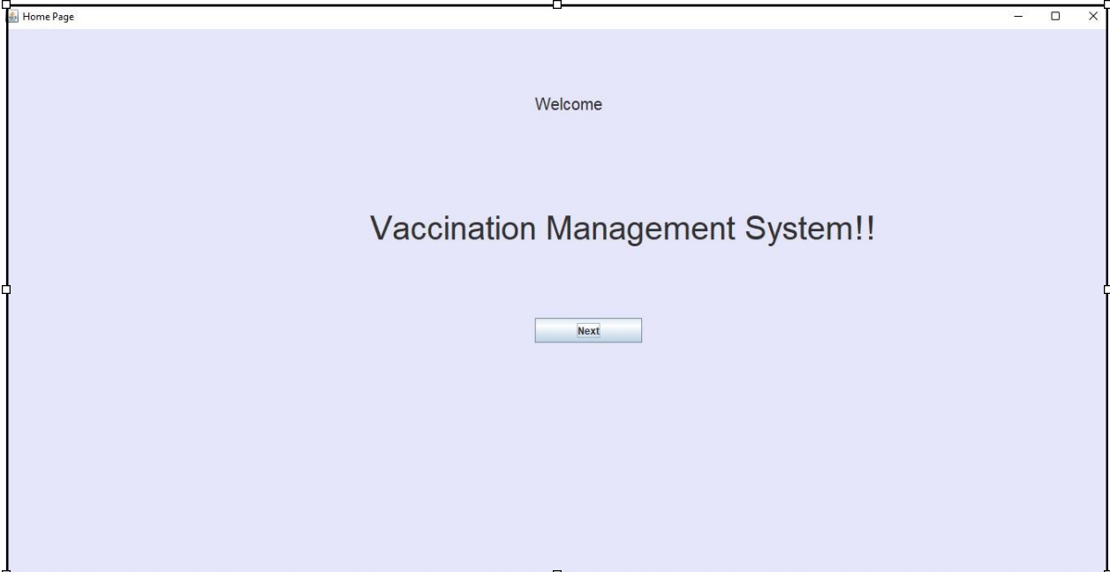

2.
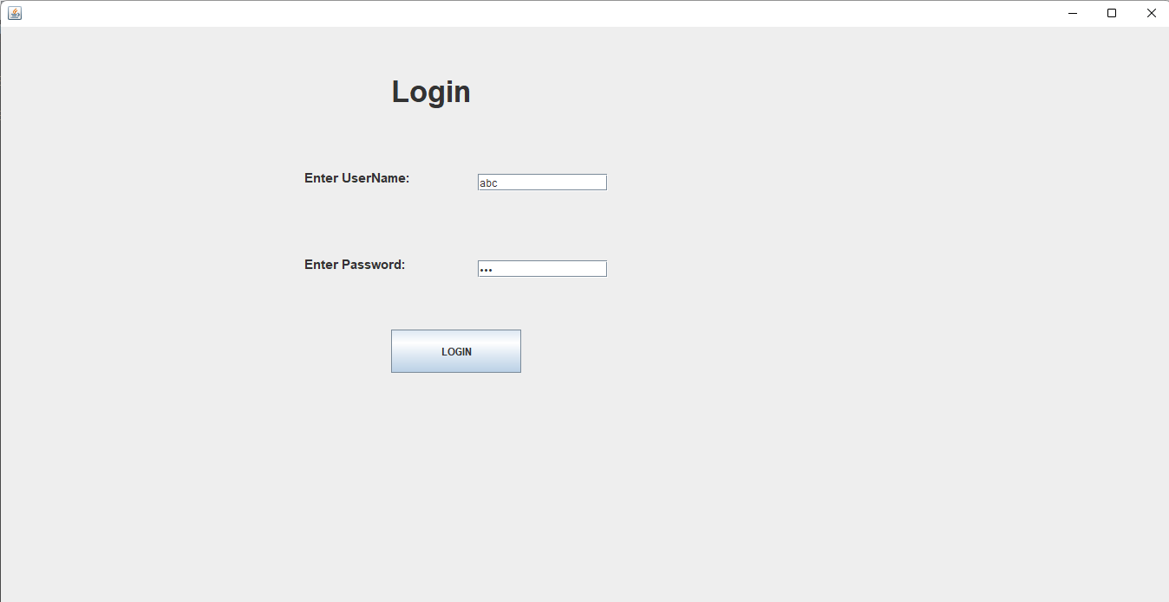

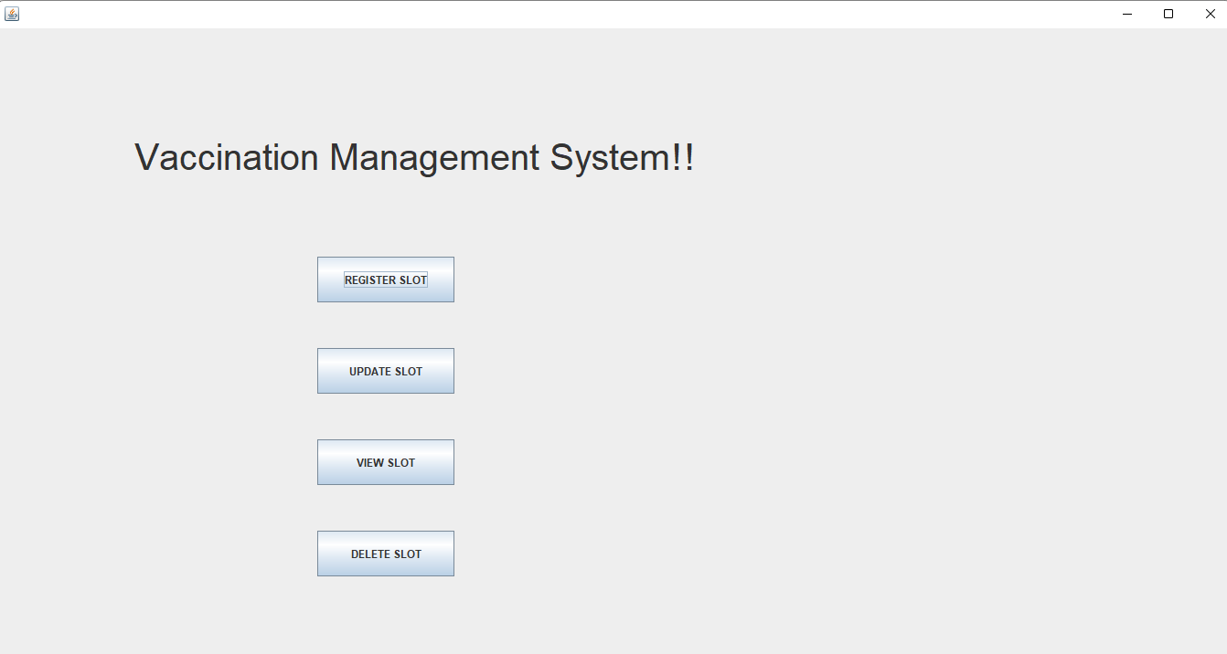

4.

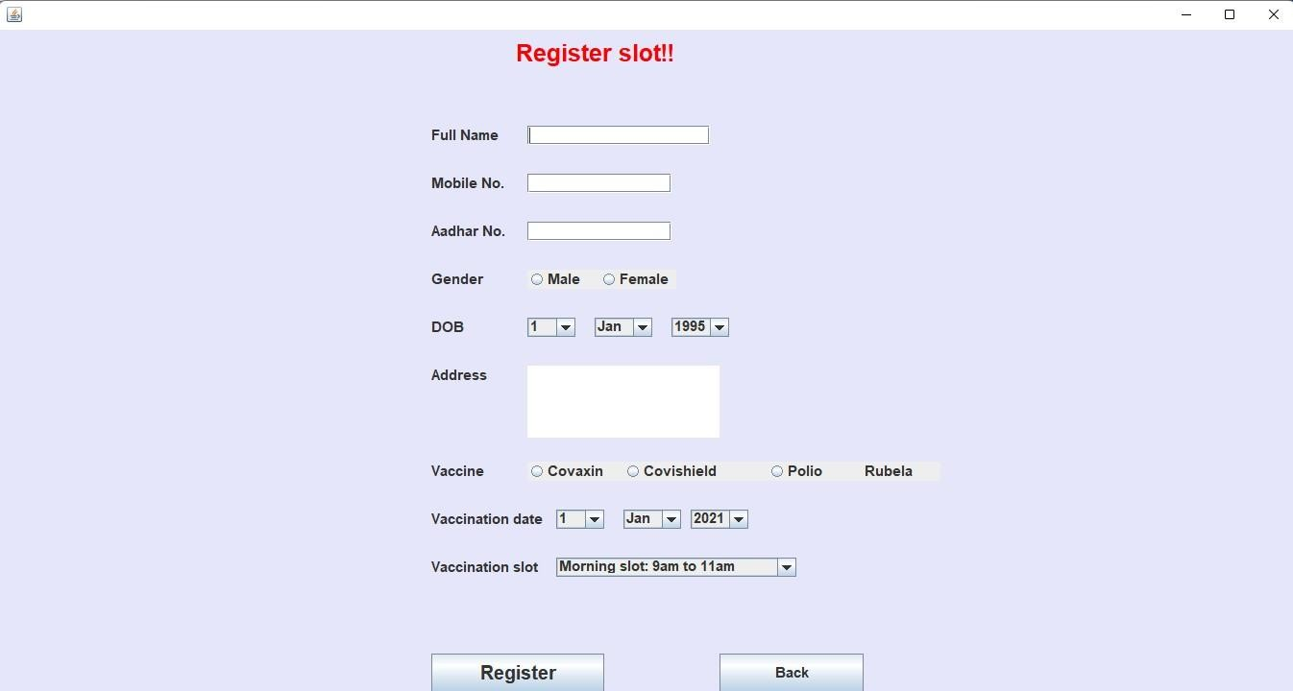

5.

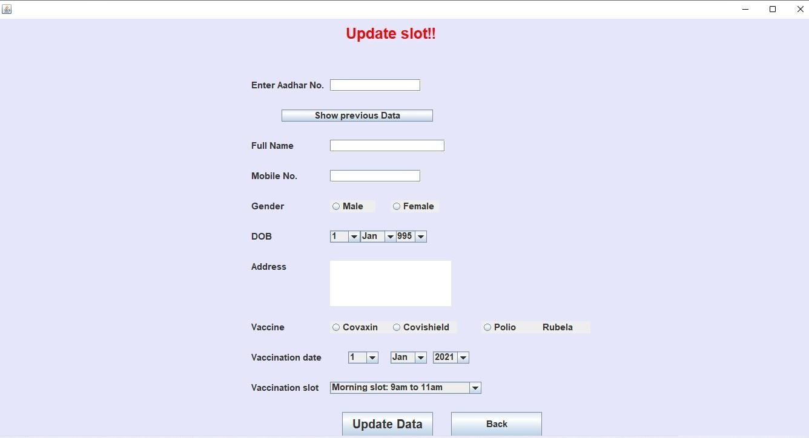

6.

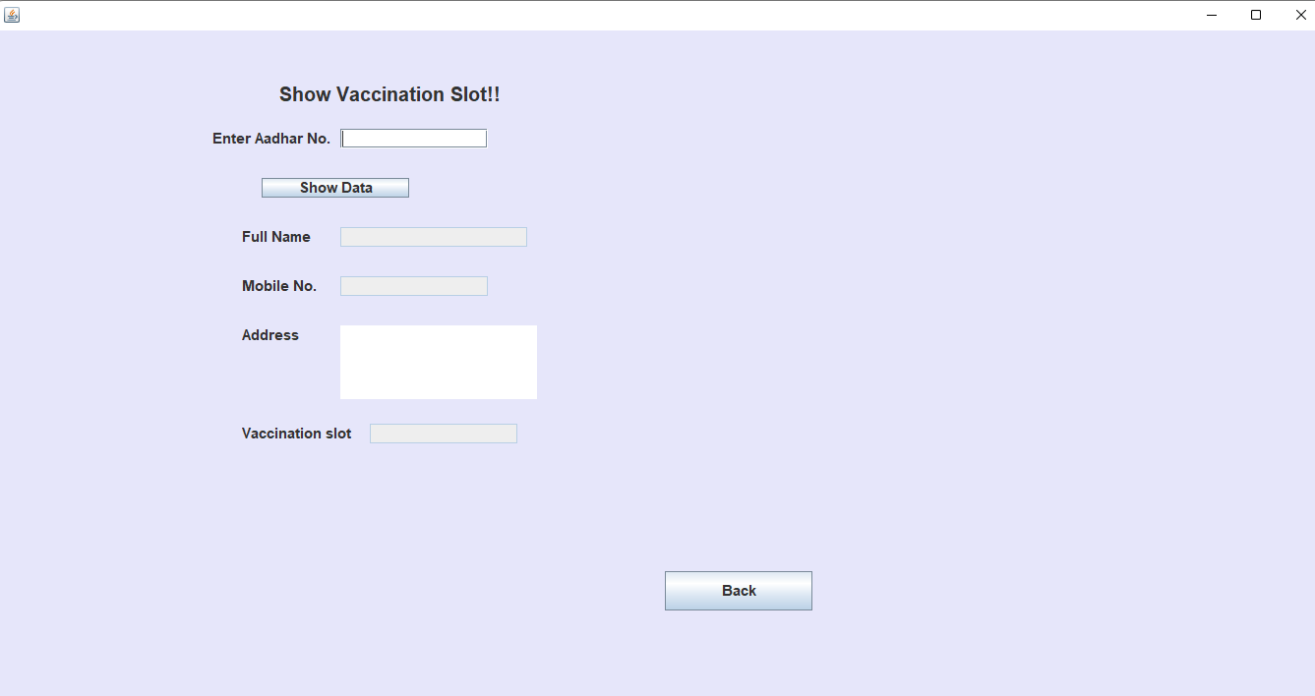

7.

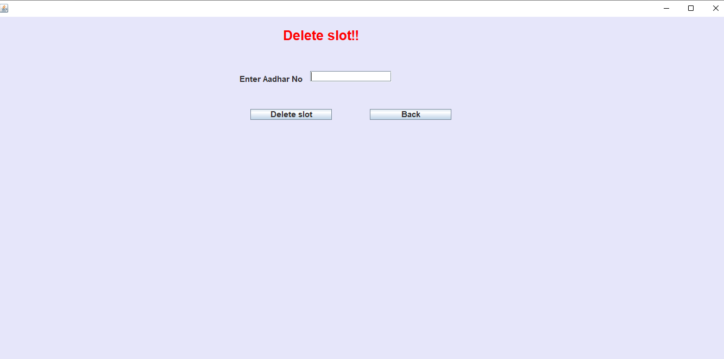

7.0 Skill Developed / learning out of this Micro-Project:

This Project is created for improving the Java programming knowledge of applications.
- The concept of project understood.
- Implementation of the self-development process.
- The structure and requirement of proposal and report understood.
- How to search information and use of different online tools come to know.

8.0 Conclusion :
Thus, we have successfully develop Vaccination Management System using Advance Component in Java And also use Event handling Concept.

Annexure – III

Teacher Evaluation Sheet Name of Student: Name of Program :

Enrollment No.: Semester: _

Course Title: Code: Title of the Micro-Project: Course Outcomes Achieved:

Evaluation as per suggested Rubric for Assessment of Micro-Project (Please tick in appropriate cell for each characteristic)
Sr.  No. | Characteristic to be assessed | Poor  ( Marks 1 -3  ) | Average  ( Marks 4 -5  ) | Good  ( Marks 6 -8  ) | Excellent ( Marks 9 -  10)
1 | Relevance to the course
2 | Literature survey /  Information collected
3 | Project Proposal
4 | Completion of target as  per project proposal
5 | Analysis of data and  representation
6 | Quality of prototype /  Model
7 | Report Preparation
8 | Presentation
9 | Defense

Micro-Project Evaluation Sheet

 | Process assessment |  | Product assessment
Seat No. | Part A Project Proposal  ( 2 marks ) | Project Methodology ( 2 marks ) | Part B Project  Report/Working Model  ( 2 marks ) | Individual Presentation  /Viva  ( 4 marks ) | Total Marks  10

Note: Every course teacher is expected to assign marks for group evaluation in first 3 columnsand individual evaluation in 4th column for each group of students as per suggested rubrics.

Comments / suggestion about team work / leadership / inter-personal communication (if any):

Any other Comment:

Name and designation of faculty member:

Signature:

Annexure – III

Teacher Evaluation Sheet Name of Student: Name of Program :

Enrollment No.: Semester: _

Course Title: Code: Title of the Micro-Project: Course Outcomes Achieved:

Evaluation as per suggested Rubric for Assessment of Micro-Project (Please tick in appropriate cell for each characteristic)
Sr.  No. | Characteristic to be assessed | Poor  ( Marks 1 -3  ) | Average  ( Marks 4 -5  ) | Good  ( Marks 6 -8  ) | Excellent ( Marks 9 -  10)
1 | Relevance to the course
2 | Literature survey /  Information collected
3 | Project Proposal
4 | Completion of target as  per project proposal
5 | Analysis of data and  representation
6 | Quality of prototype /  Model
7 | Report Preparation
8 | Presentation
9 | Defense

Micro-Project Evaluation Sheet

 | Process assessment |  | Product assessment
Seat No. | Part A Project Proposal  ( 2 marks ) | Project Methodology ( 2 marks ) | Part B Project  Report/Working Model  ( 2 marks ) | Individual Presentation  /Viva  ( 4 marks ) | Total Marks  10

Note: Every course teacher is expected to assign marks for group evaluation in first 3 columnsand individual evaluation in 4th column for each group of students as per suggested rubrics.

Comments / suggestion about team work / leadership / inter-personal communication (if any):

Any other Comment:

Name and designation of faculty member:

Signature:

Annexure – III

Teacher Evaluation Sheet Name of Student: Name of Program :

Enrollment No.: Semester: _

Course Title: Code: Title of the Micro-Project: Course Outcomes Achieved:

Evaluation as per suggested Rubric for Assessment of Micro-Project (Please tick in appropriate cell for each characteristic)
Sr.  No. | Characteristic to be assessed | Poor  ( Marks 1 -3  ) | Average  ( Marks 4 -5  ) | Good  ( Marks 6 -8  ) | Excellent ( Marks 9 -  10)
1 | Relevance to the course
2 | Literature survey /  Information collected
3 | Project Proposal
4 | Completion of target as  per project proposal
5 | Analysis of data and  representation
6 | Quality of prototype /  Model
7 | Report Preparation
8 | Presentation
9 | Defense

Micro-Project Evaluation Sheet

 | Process assessment |  | Product assessment
Seat No. | Part A Project Proposal  ( 2 marks ) | Project Methodology ( 2 marks ) | Part B Project  Report/Working Model  ( 2 marks ) | Individual Presentation  /Viva  ( 4 marks ) | Total Marks  10

Note: Every course teacher is expected to assign marks for group evaluation in first 3 columnsand individual evaluation in 4th column for each group of students as per suggested rubrics.

Comments / suggestion about team work / leadership / inter-personal communication (if any):

Any other Comment:

Name and designation of faculty member:

Signature:

Annexure – III

Teacher Evaluation Sheet Name of Student: Name of Program :

Enrollment No.: Semester: _

Course Title: Code: Title of the Micro-Project: Course Outcomes Achieved:

Evaluation as per suggested Rubric for Assessment of Micro-Project (Please tick in appropriate cell for each characteristic)
Sr.  No. | Characteristic to be assessed | Poor  ( Marks 1 -3  ) | Average  ( Marks 4 -5  ) | Good  ( Marks 6 -8  ) | Excellent ( Marks 9 -  10)
1 | Relevance to the course
2 | Literature survey /  Information collected
3 | Project Proposal
4 | Completion of target as  per project proposal
5 | Analysis of data and  representation
6 | Quality of prototype /  Model
7 | Report Preparation
8 | Presentation
9 | Defense

Micro-Project Evaluation Sheet

 | Process assessment |  | Product assessment
Seat No. | Part A Project Proposal  ( 2 marks ) | Project Methodology ( 2 marks ) | Part B Project  Report/Working Model  ( 2 marks ) | Individual Presentation  /Viva  ( 4 marks ) | Total Marks  10

Note: Every course teacher is expected to assign marks for group evaluation in first 3 columnsand individual evaluation in 4th column for each group of students as per suggested rubrics.

Comments / suggestion about team work / leadership / inter-personal communication (if any):

Any other Comment:

Name and designation of faculty member:

Signature:

